Digital Humans & Character Animation
Milestone 1: Representation & Foundations
Skeletal Hierarchy, Forward Kinematics & Linear Blend Skinning
Submitted Report

0. Milestone Overview
This milestone builds the foundational representation layer for a digital-human character animation system: a mathematically-derived joint hierarchy, forward kinematics, and Linear Blend Skinning (LBS), implemented from first principles in NumPy and validated with a working, renderable prototype.
Requirement | Where it is satisfied
Custom mathematical foundation | Section 1 — quaternion algebra, homogeneous transforms (derived, not imported)
Core system representation | Section 2 — Skeleton / Joint hierarchy with Forward Kinematics
Basic functional output mechanism | Section 4 — rendered bind pose, posed frame, and animation
Working prototype | digital_human_core.py + build_prototype.py (attached)
Mathematical derivation | Sections 1–3 of this report
System design explanation | Section 5 of this report

1. Mathematical Foundation

1.1 Rotation Representation: Why Quaternions
A joint's orientation lives in SO(3). Three candidate representations were considered:
Representation | Limitation
Euler angles (yaw / pitch / roll) | Gimbal lock — two axes can align and a degree of freedom is lost; interpolation is non-uniform.
Raw rotation matrices | 9 numbers for 3 true degrees of freedom; must be re-orthonormalized after interpolation.
Unit quaternions (chosen) | 4 numbers, no gimbal lock, compose via one Hamilton product, interpolate smoothly via slerp.
A quaternion is defined as q = w + xi + yj + zk, stored as the 4-vector [w, x, y, z], with basis elements satisfying i² = j² = k² = ijk = −1.
Encoding a rotation of angle θ about a unit axis â:
q = [ cos(θ/2), sin(θ/2) · â ]
This follows from the double-cover of SO(3) by the unit quaternions (Spin(3)): rotating a vector by θ about â corresponds to the conjugation v' = q v q⁻¹, and the half-angle arises because q and −q represent the same rotation.
Composition (Hamilton product). For q1 = [w1,x1,y1,z1], q2 = [w2,x2,y2,z2], applying q2 then q1:
q1*q2 = [ w1w2 − x1x2 − y1y2 − z1z2,
w1x2 + x1w2 + y1z2 − z1y2,
w1y2 − x1z2 + y1w2 + z1x2,
w1z2 + x1y2 − y1x2 + z1w2 ]
This is exactly the algebra implemented in quat_multiply, and it is implicitly what happens whenever Forward Kinematics composes a chain of joint orientations down the skeleton.
Quaternion → rotation matrix. For a unit quaternion, expanding q v q⁻¹ for the basis vectors e1, e2, e3 and collecting coefficients gives:
R = | 1−2(y²+z²) 2(xy−wz) 2(xz+wy) |
| 2(xy+wz) 1−2(x²+z²) 2(yz−wx) |
| 2(xz−wy) 2(yz+wx) 1−2(x²+y²) |
This matrix is what gets embedded into the 4×4 homogeneous transform used by both FK and skinning.
Slerp (spherical linear interpolation). For unit quaternions q0, q1 separated by angle θ0 = arccos(q0·q1):
slerp(q0, q1, t) = [sin((1−t)θ0)/sin(θ0)]·q0 + [sin(t·θ0)/sin(θ0)]·q1
This traces the shortest great-circle path on the 4D unit hypersphere, giving constant angular velocity — the correct way to interpolate orientation between keyframes. It is used to drive the animation output in Section 4.

1.2 Homogeneous Transforms
A joint's local pose (rotation R plus translation t relative to its parent) is packed into a single 4×4 matrix so rotation and translation compose uniformly through matrix multiplication:
T = | R t |
| 0 1 |
A point p is transformed by extending it to homogeneous coordinates [p,1]ᵀ and computing T·[p,1]ᵀ. Critically, chained transforms compose by simple matrix multiplication: T_total = T1·T2·T3… — exactly what a joint hierarchy needs.

2. Core System Representation: Skeleton & Forward Kinematics
The skeleton is represented as a tree of joints. Each joint j stores a local transform L_j (its bind-pose offset from its parent, composed with an animatable local rotation). The world transform of every joint is defined recursively:
W_root = L_root
W_j = W_parent(j) · L_j
This recurrence is a direct consequence of the associativity of homogeneous transforms: the world position of, say, a wrist is the accumulated product of the hip, spine, chest, shoulder, and elbow transforms — rotating the shoulder automatically moves everything downstream, which is the entire purpose of a hierarchical rig.
The prototype implements a 13-joint humanoid: hips → spine → chest → neck → head, two arms (shoulder → elbow → wrist), and one leg (hip → knee) — enough branching depth to demonstrate a real hierarchy while keeping Milestone 1 minimal.

3. Linear Blend Skinning (LBS)
Bind pose. Let B_j be joint j's world transform when the skeleton is in its reference T-pose. Every mesh vertex v is authored in this bind pose's world space.
Skinning weights. Each vertex is assigned a small set of (joint, weight) pairs {(j, w_j)} with Σ w_j = 1. In this prototype, weights are assigned procedurally along each bone: a vertex at parametric position t ∈ [0,1] along the tube from the parent joint to the child joint receives weight (1−t) on the parent and t on the child — a smooth linear blend that avoids the classic “candy-wrapper” collapse of rigid single-joint binding at the elbow or knee.
Deformation. Given a new pose with world transforms W_j (computed via FK above), each vertex is deformed by:
v_deformed = Σⱼ wⱼ · ( Wⱼ · Bⱼ⁻¹ ) · v_bind
Derivation: B_j⁻¹ maps the bind-pose vertex out of world space and into joint j's own local (bind) frame. Left-multiplying by W_j then maps that same local-frame point back into world space using the joint's current (posed) transform instead of its bind transform. So (W_j·B_j⁻¹) is precisely “the rigid motion joint j underwent since the bind pose,” applied to the vertex. Blending several such joint-relative motions by weight produces a smooth deformation across a joint — the standard LBS equation used throughout production animation and game engines, and the direct analogue of what a GPU skinning shader computes per vertex.

3.1 Computational Pipeline Summary
joint local rotations (quaternions)
│ quat_to_matrix + translation
▼
per-joint local transform L_j (4x4)
│ recursive FK: W_j = W_parent(j) · L_j
▼
per-joint world transform W_j (4x4)
│ combined with per-joint inverse bind B_j⁻¹
▼
per-vertex skinning matrix W_j · B_j⁻¹
│ weighted sum over influencing joints
▼
deformed mesh vertex positions → rendered output
Every stage above is implemented from first principles in digital_human_core.py using only NumPy for linear-algebra storage — no external animation or rigging library.

4. Basic Functional Output
The prototype renders three artifacts that demonstrate the full pipeline running end-to-end.

4.1 Bind Pose (T-Pose)
The skeleton in its reference pose, with the LBS-skinned tube mesh generated over every bone.
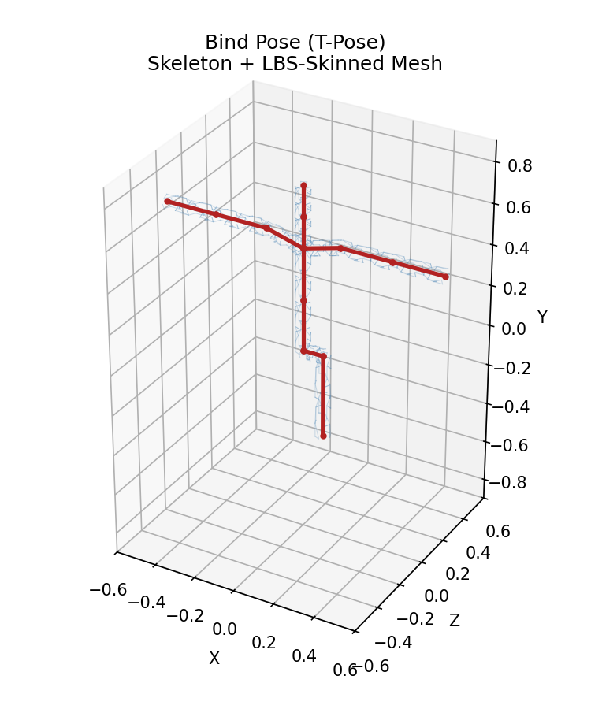
Figure 1. Bind pose: skeleton (red) and skinned mesh (blue wireframe).

4.2 Posed Frame
Joint local rotations are set directly (left shoulder raised, both elbows bent, left knee bent, spine twisted); Forward Kinematics propagates these through the hierarchy and LBS deforms the mesh accordingly.
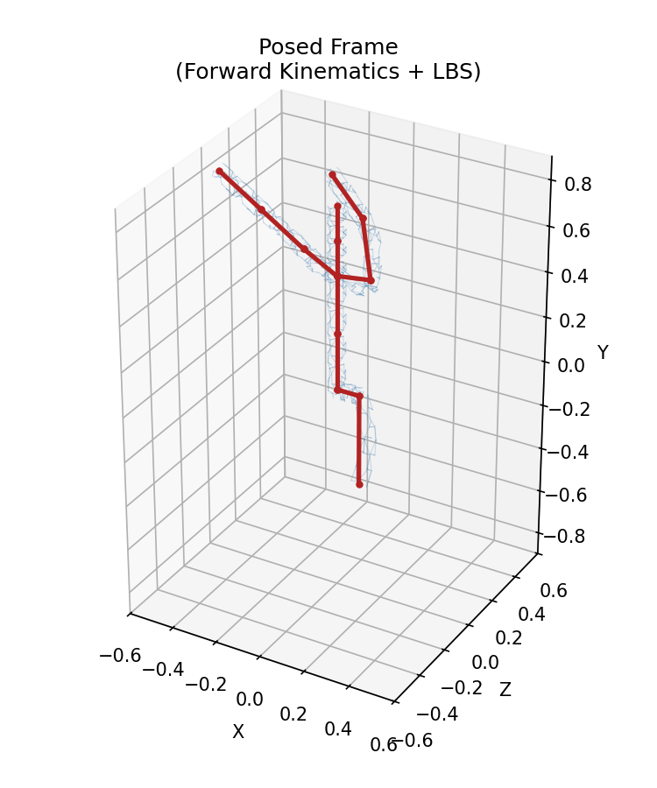
Figure 2. Posed frame produced by Forward Kinematics + LBS.

4.3 Animation
Every animated joint's rotation is interpolated from bind pose to the target pose using slerp (Section 1.1) over 24 frames, re-run through FK and LBS each frame. A representative mid-sequence frame is shown below; the full animation is supplied separately as animation.gif.
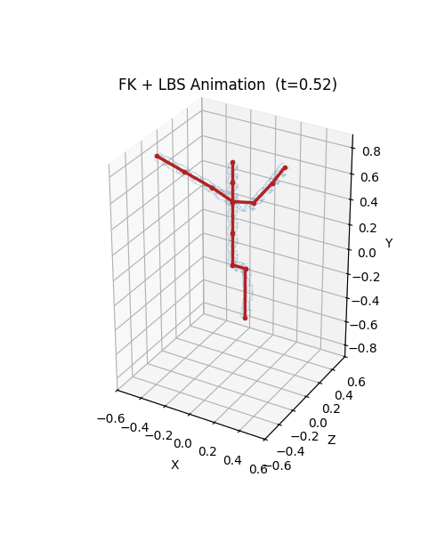
Figure 3. Mid-sequence frame from the slerp-driven animation (see animation.gif for the full sequence).

5. System Design Explanation

5.1 Scope of This Milestone
This milestone builds the minimal representation layer every later milestone sits on top of: a joint hierarchy, a way to pose it (FK), a way to bind geometry to it (skinning), and a way to see the result (render). Inverse kinematics, motion-capture retargeting, facial rigs, and physics are explicitly deferred to later blocks.

5.2 Architecture
digital_human_core.py
├── Quaternion algebra (quat_from_axis_angle, quat_multiply, quat_to_matrix, quat_slerp)
├── Homogeneous transforms (make_transform, transform_point)
├── Skeleton / Joint (hierarchy, local rotations, forward_kinematics())
├── Procedural tube mesh (make_tube_mesh — no external mesh assets needed)
└── SkinnedMesh (add_bone_tube, bind, deform — Linear Blend Skinning)
build_prototype.py
├── Defines a 13-joint humanoid skeleton (hips → spine/chest/neck/head,
│ two arms, one leg — enough to demonstrate hierarchy depth and branching)
├── Generates a skinned tube mesh over every bone
└── Renders: bind_pose.png, posed.png, animation.gif
Why this decomposition:
- Separation of skeleton from mesh. Skeleton knows nothing about geometry; SkinnedMesh knows nothing about how a pose is authored — mirroring production rigs (e.g. FBX/USD skeletons vs. skinned meshes) so later milestones (IK solvers, retargeting, ML-driven pose prediction) can plug into the same Skeleton object without touching skinning code.
- Everything reduces to 4×4 matrices. Quaternions only ever build a local transform; FK and skinning operate purely on homogeneous matrices, making the FK recurrence a one-line matrix product instead of special-cased rotation/translation bookkeeping.
- Procedural geometry instead of an imported mesh. For a first-principles milestone, the tube mesh is generated analytically from bone endpoints, so the whole pipeline — geometry, rig, skinning, rendering — is self-contained and auditable. Later milestones can swap in an authored humanoid mesh with real per-vertex weights without changing the skinning math.

5.3 Data Flow (Per Frame)
- Each joint's local_rotation (a quaternion) is set — directly, or via slerp against the bind rotation.
- Skeleton.forward_kinematics() walks the hierarchy once, producing world transforms.
- SkinnedMesh.deform() applies the LBS equation per vertex using those world transforms and the precomputed inverse-bind matrices.
- Matplotlib renders the skeleton (bones + joints) and the translucent skinned surface in the same 3D axes.

5.4 Known Simplifications (Intentional — Addressed in Later Blocks)
- Skinning weights are procedurally assigned along a single bone (parent↔child blend) rather than authored/painted across multiple influencing joints — sufficient to demonstrate the LBS math, but a production character mesh needs multi-joint weight painting.
- No collision, joint limits, or physical constraints — pure kinematics.
- No IK yet — poses are set directly in joint-local rotation space (forward, not inverse).
- Single-view matplotlib rendering — sufficient to validate the pipeline; a later milestone will likely move to a real-time renderer (OpenGL/three.js) for interactivity.

5.5 What This Proves for Milestone 1
- Custom mathematical foundation: quaternions and homogeneous transforms are derived and implemented from scratch (Sections 1–3), not pulled from a library.
- Core system representation: a joint hierarchy with FK, plus a mesh bound to it via real skinning weights — the representation every later milestone extends.
- Basic functional output: posing the skeleton visibly and correctly deforms the mesh (Figures 1–2), and the animation shows continuous, gimbal-lock-free interpolation between poses — an end-to-end, runnable prototype rather than a paper design.

6. Deliverables
File | Contents
digital_human_core.py | Quaternion math, transforms, Skeleton/FK, procedural mesh, LBS
build_prototype.py | Skeleton definition, mesh binding, posing, rendering driver
bind_pose.png | T-pose skeleton + skinned mesh
posed.png | Posed skeleton + mesh via FK + LBS
animation.gif | Slerp-interpolated animation from bind pose to target pose
M1_Report.docx | This report

